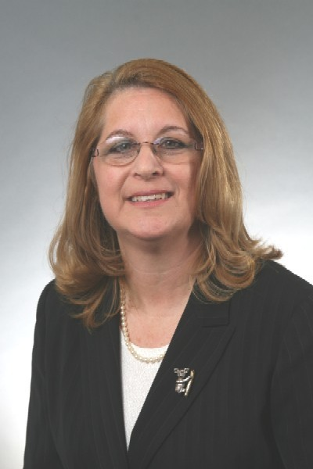 |  | Cynthia s. sobel,  C.p.A.  Managing Member
Profile  A Certified Public Accountant with over 40 years’ experience.  My passion is assisting individuals and companies to meet their financial needs through effective tax and financial planning.  My priority is providing businesses with tools and resources for effective monitoring of their business goals.  I prepare accurate federal, state, and local tax returns.  Contact  PHONE:  954-744-8440  WEBSITE:  https://theflacpa.com/  EMAIL:  csobel@theflacpa.com  Skills  - Able to train clients in the use of QuickBooks  - Able to adapt to any accounting program  - Able to assist in the setup of new businesses and the streamlining accounting processes |  | EDUCATION  University of North Carolina – Chapel Hill  Bachelor of Science in Business Administration, 1981  WORK EXPERIENCE  Rosenbaum Sobel Weinrub LLC – Managing Member & Co-Founder  2011–Present  Dawson Rosenbaum & Sobel, P.A - Partner  2006–2011  Sobel Glackman & Sobel, P.A - Partner  1982 - 2006  Certifications and Memberships  Florida Certified Public Accountant, August 1982  American Institute of Certified Public Accountants  Florida Institute of Certified Public Accountants  Temple Israel of Greater Miami – Sisterhood Board Member

